|  |  |
| --- | --- |
| **Passive Optical Components** | **MPO Optical Connector** |
|  |  |

MPO Connector is a kind of optical fiber connector which is featured with high-speed transmission. It is widely used inpremade end of the main cable, or high-density center data transmission, Optical Splitteror inside the 40 G/100 G SFP, QSFP+, etc. optical transceiver.

.

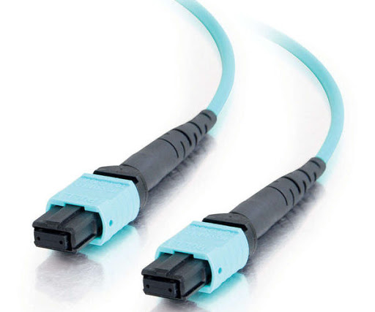

|  |  |
| --- | --- |
| **FEATURES** | **APPLICATIONS** |
|  |  |
| **●Terminates ribbon fiber or loose individual fibers** | **●Array trunk cables** |
| **●Low Loss** | **●Array fiber to single fiber fan-outs and cassettes** |
| **●Alignment achieved with high precision guide pins** | **●High fiber density card edge access** |
|  | **●Optical switching interframe connections** |
|  |  |

|  |  |  |  |
| --- | --- | --- | --- |
| **Item** |  | **Parameter** | |
|  |  |  |  |
| **Connector Type** |  |  | MTP |
|  |  |  | |
| **Cable Type** |  | Multi mode OM4 | |
|  |  |  |  |
| **Cores** |  |  | 8 |
|  |  |  |  |
| **Cable Diameter** |  |  | 3.5mm |
|  |  |  |  |
| **Material** |  |  | LSZH |
|  |  |  | |
| **Color** |  | Purple(color #：PANTONE 2587U) | |
|  |  |  |  |
| **Cable Loss** |  | @850nm 3.5dB/km | @1300nm 1.5dB/km |
|  |  |  |  |
| **Insertion Loss** |  | ≤1.75dB @850nm | ≤1.15dB @1300nm |
|  |  |  | |
| **Reference Standard** |  | Plug performance meets the< GR-1435-CORE>(Controlled environment) | |
|  |  |  |  |